South Australia
Adelaide Railway Station Development Act 1984
An Act to facilitate the development of the site of the Adelaide Railway Station by the construction of a hotel of international standard, an office tower and other improvements; and for other purposes.

Contents
1 Short title
3 Interpretation
4 Vesting of land
5 The development
6 Exemption from certain Acts
7 Access to development site
8 Promulgation of development plan by regulation
Schedule
Legislative history

The Parliament of South Australia enacts as follows:
1—Short title
This Act may be cited as the Adelaide Railway Station Development Act 1984.
3—Interpretation
In this Act, unless the contrary intention appears—
the contracting parties means—
(a) the State; and
(b) South Australian Superannuation Fund Investment Trust; and
(c) Kumagai Gumi Co. Ltd.; and
(d) Aser Property Trust;
the development plan means a plan promulgated by regulation for development of the development site;
the development site means the land comprised in Section 766 Hundred of Adelaide and the land marked "V" in the Schedule;
the Minister means the Minister of Public Works;
the proposed development means the development of the development site in accordance with the development plan.
4—Vesting of land
(1) An estate in fee simple in the land comprised in Section 766 Hundred of Adelaide is vested in the State Transport Authority.
(2) An estate in fee simple in the land marked "T" in the plan deposited in the General Registry Office at Adelaide and numbered No. 112 of 1984 is vested in the Corporation of the City of Adelaide.
(3) Any estate or interest in the land comprised in Section 766 Hundred of Adelaide or in the land marked "T" in the plan deposited in the General Registry Office at Adelaide and numbered No. 112 of 1984 that existed immediately before the commencement of this section is extinguished.
(4) The Registrar-General, on the application of a body in which land is vested under this section, shall, without payment of a fee, issue a certificate of title under the provisions of the Real Property Act 1886 in respect of that land.
(5) The Registrar-General shall make all consequential amendments to the Register Book that become necessary by reason of the issue of a Certificate of Title pursuant to subsection (4).
(6) No duty is payable pursuant to the Stamp Duties Act 1923 in respect of an application referred to in subsection (4).
5—The development
(1) It shall be lawful to develop the development site in accordance with the development plan.
(2) No consent, approval or other authorisation is required under the City of Adelaide Development Control Act 1976 in respect of the proposed development.
(3) To facilitate the proposed development, the Minister may grant such exemptions from the Building Act 1970 as he thinks fit.
(4) An exemption granted pursuant to subsection (3) shall be subject to such conditions as the Minister determines and an exemption, or a condition to which an exemption is subject, may be varied or revoked by the Minister at any time.
(5) Within six sitting days after the Minister grants or varies an exemption referred to in subsection (3) or varies a condition to which such an exemption is subject, he shall cause to be laid before each House of Parliament a written statement of—
(a) the nature and extent of the exemption;
(b) the person for whose benefit the exemption will operate;
(c) the conditions (if any) to which the exemption is subject;
(d) his reasons for granting or varying the exemption or the condition.
(6) A person who contravenes or fails to comply with a condition attached to an exemption granted pursuant to subsection (3) is guilty of an offence.
Penalty: Fifty thousand dollars.
(7) Where a person contravenes or fails to comply with a condition attached to an exemption granted pursuant to subsection (3), the Minister may, by notice in writing, require him to desist from the contravention or remedy the default and if he fails to comply with the notice he shall be guilty of an offence and liable to a penalty not exceeding five thousand dollars for every day for which that failure continues.
(8) The exemption conferred by subsection (2) shall expire on the thirtieth day of June, 1991, and an exemption granted pursuant to subsection (3) shall expire on or before that date.
6—Exemption from certain Acts
(1) An agreement between the State and any one or more of the contracting parties relating to the proposed development may confer an exemption from any rate, tax, duty or other impost under—
(a) the Waterworks Act 1932; or
(b) the Sewerage Act 1929; or
(c) the Local Government Act 1934; or
(d) the Land Tax Act 1936; or
(e) the Stamp Duties Act 1923.
(2) An exemption under subsection (1)(a), (b) or (c) shall expire before the first day of July, 1991, or such other date as may be agreed between the State and the other parties concerned.
(3) An exemption under subsection (1)(d) shall expire before the first day of July, 1996, or such other date as may be agreed between the State and the other parties concerned.
(4) An exemption under subsection (1)(e) shall relate only to documents executed before the first day of July, 1991, or such other date as may be agreed between the State and the other parties concerned.
7—Access to development site
(1) In order to facilitate the proposed development, the Minister may, subject to this section, by notice published in the Gazette—
(a) confer upon any person access to the development site over specified municipal land; and
(b) confer upon any person exclusive rights of occupation in respect of specified municipal land that is immediately adjacent to the development site.
(2) In subsection (1)—
municipal land means land that—
(a) is vested in the Corporation of the City of Adelaide; or
(b) is under the care, control or management of the Corporation.
(3) The Minister shall not publish a notice pursuant to subsection (1) without first conferring with the Corporation of the City of Adelaide as to the rights to be conferred by the proposed notice.
(4) Any rights of access or occupation conferred pursuant to this section shall cease to operate after the completion of the proposed development.
8—Promulgation of development plan by regulation
(1) The Governor may, by regulation—
(a) promulgate a plan for development of the development site; or
(b) amend a plan so promulgated.
(2) At least thirty days before a plan is promulgated as the development plan, or before the development plan is amended, the Minister responsible for planning shall invite representations in relation to the proposed plan or amendment from the Corporation of the City of Adelaide and the City of Adelaide Planning Commission and he shall have regard to any representations made in response to that invitation.

Schedule
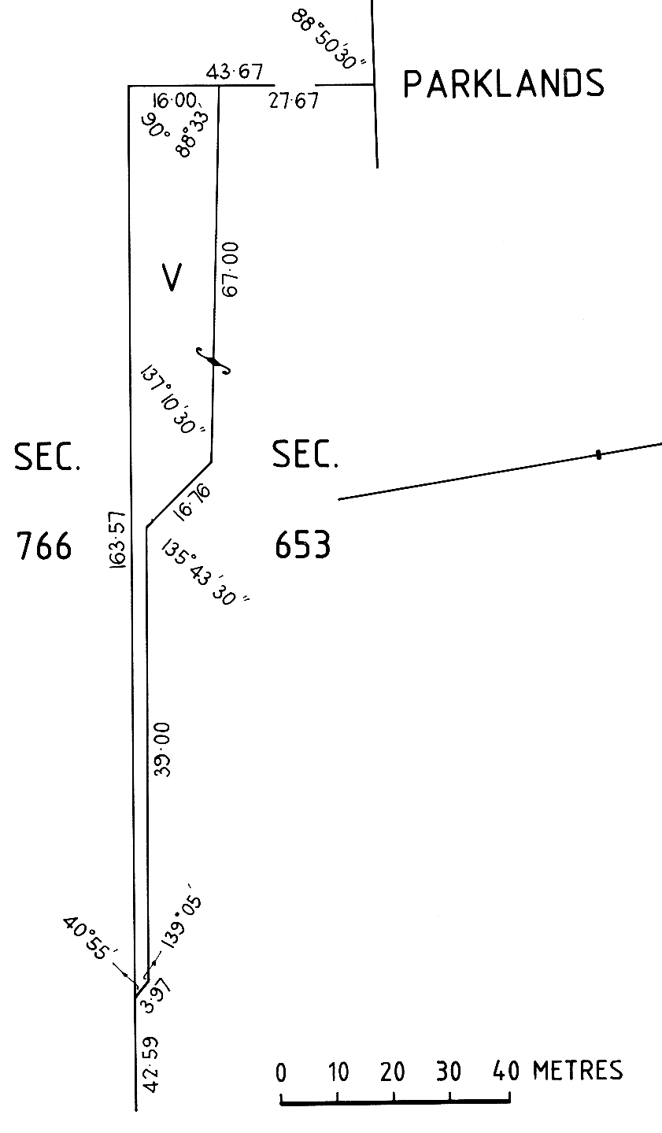

Legislative history
Notes
• For further information relating to the Act and subordinate legislation made under the Act see the Index of South Australian Statutes or www.legislation.sa.gov.au.
Principal Act
Year | No | Title | Assent | Commencement
1984 | 31 | Adelaide Railway Station Development Act 1984 | 10.5.1984 | 26.7.1984 (Gazette 26.7.1984 p332)
Provisions amended
New entries appear in bold.
Entries that relate to provisions that have been deleted appear in italics.
Provision | How varied | Commencement
s 2 | omitted under Legislation Revision and Publication Act 2002

